Social-Epistemic Nexus Analytics in the Generative AI Era:
A Conceptual Framework and Web-Based System for People-Ideas Learning Analytics
Dongpin Hu¹, Yun-Fang Tu²,³, Dragan Gašević⁴, David W. Shaffer⁵, and Gwo-Jen Hwang⁶*
¹ Department of Curriculum and Instruction, The Education University of Hong Kong, Hong Kong SAR, China
² Department of Data Science, Soochow University, Taipei, Taiwan
³ Empower Vocational Education Research Center, National Taiwan University of Science and Technology, Taipei, Taiwan
⁴ Centre for Learning Analytics and Department of Data Science and Artificial Intelligence, Faculty of Information Technology, Monash University, Melbourne, Australia
⁵ Department of Educational Psychology and Wisconsin Center for Education Research, University of Wisconsin-Madison, Madison, WI, USA
⁶ Graduate Institute of Digital Learning and Education, National Taiwan University of Science and Technology, Taipei, Taiwan
* Corresponding author: Gwo-Jen Hwang. Email: [Email to be verified]
Manuscript type: Conceptual paper. This manuscript describes a prototype system under development and reports no empirical validation study.

Highlights
- The paper proposes Social-Epistemic Nexus Analytics (SENA) as a framework for linking people, ideas, and time in collaborative learning.
- SENA extends Social Epistemic Network Signature (SENS) from a pattern or signature metaphor to a multi-layer nexus for process-oriented learning analytics.
- A web-based SENA prototype is described through three functions: Dual Lens Dashboard, SENA Fusion Canvas, and Temporal SENA Trace.
- Generative AI is positioned as a human-reviewed analytic partner for coding support, interpretation drafts, and teaching or research reporting.
- Responsible AI, reproducibility, and future validation requirements are specified for cautious educational use.

Abstract
Learning analytics increasingly operates in an era in which generative artificial intelligence can assist data preparation, discourse coding, visual interpretation, and report writing. Yet the field also needs theory-guided frameworks that keep analytic automation connected to learning processes. This conceptual paper introduces Social-Epistemic Nexus Analytics (SENA), a theoretical and methodological framework for analyzing collaborative learning as a dynamic nexus of social relations, epistemic connections, roles, communities, temporal stages, scaffolding actions, and outcomes. SENA builds on work in social network analysis, epistemic network analysis, social learning analytics, and Social Epistemic Network Signature, but shifts from a signature metaphor to a nexus metaphor: social interaction and knowledge-building discourse are treated as mutually constitutive rather than merely adjacent evidence streams. The paper then describes an under-development web-based SENA system as a technological instantiation of the framework. The system is organized around three prototype functions: a Dual Lens Dashboard that separates social and epistemic views for transparent inspection, a SENA Fusion Canvas that visualizes who interacts with what ideas, and a Temporal SENA Trace that follows social-epistemic development across phases of collaboration. We argue that SENA can support learning analytics and learning sciences by making people-ideas relations inspectable while preserving human review, methodological transparency, and ethical caution. The paper concludes with design principles and a research agenda for validating SENA indicators, AI-assisted interpretation, and human-AI collaboration in discourse-rich learning settings.

Keywords
Social-Epistemic Nexus Analytics; learning analytics; epistemic network analysis; social network analysis; generative AI; collaborative learning

1. Introduction
The generative AI era has intensified a long-standing question for learning analytics: how can computational evidence help researchers and educators understand learning without reducing learning to easily counted traces? Generative AI systems can summarize discussions, classify discourse, suggest codes, generate dashboard interpretations, and draft teaching or research reports. These capabilities may lower the technical threshold for analytics work, but they also increase the risk of plausible yet weakly grounded interpretation. Learning analytics therefore needs conceptual frameworks that organize what should be modeled, why it matters for learning, and how automated assistance should remain accountable to educational theory and human judgement (Gašević et al., 2015; Miao & Holmes, 2023; Siemens, 2013).
Collaborative learning is a particularly demanding case because it is simultaneously social and epistemic. Learners do not merely exchange messages; they build, contest, elaborate, and transform ideas with others. A discussion in which one student becomes central may support deep collective reasoning, but it may also reflect domination, coordination talk, or logistical clarification. Conversely, a group may display rich concept connections in discourse while still depending on fragile or uneven social participation. The central analytic problem is thus not only who participates or what concepts occur, but how people and ideas co-develop over time (Dillenbourg, 1999; Jeong & Hmelo-Silver, 2016; Stahl et al., 2006).
Social network analysis (SNA) and epistemic network analysis (ENA) have each made important contributions to this problem. SNA models relations among actors and can reveal participation, centrality, brokerage, reciprocity, density, and community structure (Butts, 2008; Wasserman & Faust, 1994). ENA models relations among coded elements of discourse and can represent the structure of connections among concepts, practices, skills, values, or reasoning moves (Shaffer, 2017; Shaffer et al., 2016). Yet each lens has a blind spot when used alone. SNA is often content-blind: it can reveal that a learner is central but not what kinds of thinking the learner helps organize. ENA is often under-socialized: it can reveal strong evidence-explanation connections but not which social roles, ties, or communities produce them.
The Social Epistemic Network Signature (SENS) approach was introduced to address this separation by combining SNA and ENA. In a MOOC forum study, Gašević, Joksimović, Eagan, and Shaffer (2019) showed how social and cognitive perspectives can be modeled together to examine whether learners interact with particular people around particular forms of content. Subsequent SENS-oriented work has applied similar logic to teacher scaffolding in knowledge-building environments and to interdisciplinary lesson study for AI-integrated science education (Li et al., 2024; Zhao et al., 2026). This line of work demonstrates the value of treating collaborative learning as a social-epistemic phenomenon rather than as either a social network or a discourse network alone.
This paper proposes Social-Epistemic Nexus Analytics (SENA) as a conceptual extension of that line of work. The term nexus is deliberately chosen. A signature suggests a recognizable pattern at a given level of analysis. A nexus suggests a structured, evolving relational system in which actors, ideas, discourse moves, roles, communities, scaffolding, temporal stages, and outcomes are analytically connected. SENA therefore aims to function not only as a visualization but as a theory-guided analytic ecosystem for discourse-rich learning settings.
The second contribution is to describe the SENA system, a web-based prototype that instantiates the framework for research and educational use. The planned platform at www.sena.hk is treated here as under development; this paper is based on the design screenshot, project documentation, and developer-provided technical background rather than on a deployed public system. The prototype is built around three core functions: a Dual Lens Dashboard that separates SNA and ENA views, a SENA Fusion Canvas that integrates people and ideas in a social-epistemic visualization, and a Temporal SENA Trace that follows social and epistemic patterns across stages of collaborative activity.
The paper is conceptual rather than empirical. It does not claim that the SENA system has already improved learning outcomes or that its AI-generated interpretations are valid without review. Instead, it articulates a framework, explains design choices, and outlines a research agenda for future validation. The argument is that the future of learning analytics in the GenAI era should not be simple automation. It should be theory-guided, human-centered, reproducible, and capable of representing the people-ideas-time relations that make collaborative learning meaningful.
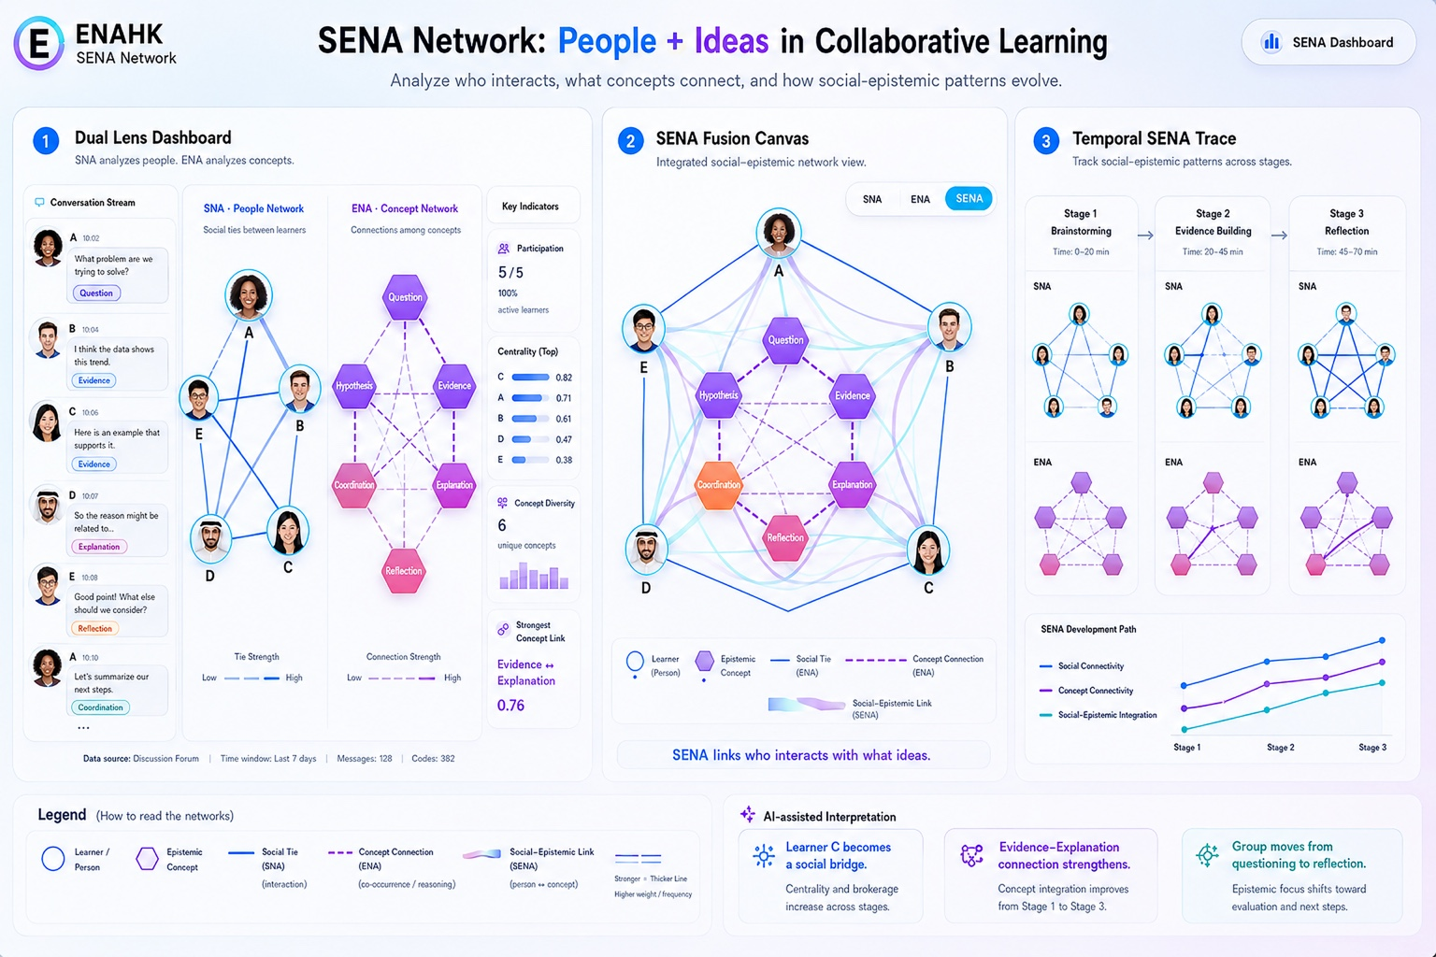
Figure 1. Prototype design of the SENA system: People + Ideas in Collaborative Learning. The screenshot shows the Dual Lens Dashboard, SENA Fusion Canvas, and Temporal SENA Trace in a single web-based prototype view.

2. Theoretical foundations: From social analytics and epistemic analytics to social-epistemic nexus
Learning analytics has been defined broadly as the measurement, collection, analysis, and reporting of data about learners and their contexts for understanding and optimizing learning. Its development has been driven by the growth of digital trace data, interest in timely feedback, and the need to connect data with educational decision-making (Ferguson, 2012; Siemens, 2013). A recurring concern, however, is that analytics must remain about learning rather than about data availability alone (Gašević et al., 2015). This concern is central to SENA: the framework begins from a theory of collaborative learning before specifying network measures or dashboard functions.
Social learning analytics sharpened this point by emphasizing that learning is often relational, participatory, and mediated by social technologies (Buckingham Shum & Ferguson, 2012). In CSCL, collaboration is not simply the aggregation of individual cognition; it involves coordination, shared attention, mutual regulation, explanation, argumentation, and the construction of shared artifacts (Dillenbourg, 1999; Stahl et al., 2006). The unit of analysis can therefore shift between individual learners, groups, communities, discourse episodes, and artifacts. Analytics that only count posts or logins may miss these interactional and epistemic qualities.
SNA offers a rigorous way to model relations in such settings. It can represent learners as nodes and interactions as edges, enabling analysis of density, reciprocity, degree centrality, betweenness centrality, brokerage, modularity, and community structures (Butts, 2008; Wasserman & Faust, 1994). In educational research, SNA has helped identify participation patterns, isolate peripheral learners, compare collaboration networks, and examine how communication structures are associated with performance or persistence. Its limitation is not the mathematics of networks but the interpretive risk of treating interaction volume or structural centrality as if it were automatically equivalent to productive learning. A central learner may be a conceptual bridge, a social coordinator, a help seeker, or a bottleneck. SNA needs content-sensitive interpretation.
ENA, by contrast, was designed to model the structure of connections among coded elements in discourse or activity. In ENA, nodes typically represent codes such as concepts, skills, practices, values, or discourse moves, and edges represent co-occurrences within specified units and windows (Shaffer, 2017; Shaffer et al., 2016). ENA is valuable because it preserves relational patterns among ideas rather than only counting code frequencies. It can show, for example, whether evidence is connected to explanation, whether critique is linked with design revision, or whether reflection connects to future planning. However, ENA alone does not automatically explain how social roles, actor positions, or interaction communities shape those epistemic patterns.
SENS combined these two traditions by using SNA and ENA together. Gašević et al. (2019) argued that collaborative learning needs both social and cognitive perspectives and demonstrated how epistemic-network similarity, social ties, centrality, communities, and performance can be analyzed in relation to one another. Their study is important not because it produced a new graph type alone, but because it provided a methodological logic: interaction and content should be jointly modeled because group interaction is never content neutral. This insight has become increasingly relevant as learning environments produce richer multimodal and discourse-based trace data.
SENA preserves this methodological continuity but reframes the target of analysis. It treats social and epistemic evidence not as two outputs to be juxtaposed, but as layers within a broader nexus that includes time, roles, scaffolding, outcomes, and AI-assisted interpretation. This reframing matters for educational technology. Dashboards and AI reports are not neutral displays of data; they shape what educators notice, what interventions are considered, and what learners may be asked to change (Jivet et al., 2018; Verbert et al., 2013; Wise & Jung, 2019). A SENA system must therefore make the assumptions behind its analytics visible and contestable.
Table 1. From SNA and ENA to SENS and SENA
Analytic tradition | Main object | Strength | Limitation | SENA extension
SNA | Actors and social ties | Reveals participation, centrality, brokerage, reciprocity, and communities. | Can be content-blind and may over-interpret structural position. | Connects social positions to epistemic contributions, roles, temporal phases, and feedback actions.
ENA | Codes, concepts, practices, or discourse moves | Models connections among epistemic elements rather than only frequencies. | Can be under-socialized if actor roles and ties are not modeled. | Links concept connections to learners, groups, communities, and interaction patterns.
SENS | Combined social and epistemic networks | Shows how learners interact with particular people around particular content. | Often treated as an integrated method or final signature rather than an end-to-end analytic ecosystem. | Becomes a platform-ready, process-oriented nexus including time, scaffolding, outcomes, and reproducibility.
SENA | Dynamic nexus of people, ideas, roles, time, scaffolding, and outcomes | Provides a theory-aligned workflow for inspection, integration, interpretation, and reporting. | Requires careful coding, transparent parameter choices, and empirical validation. | Guides the design of web-based, human-in-the-loop social-epistemic analytics systems.

3. SENA Framework: Social-Epistemic Nexus Analytics
Social-Epistemic Nexus Analytics (SENA) is a theoretical and methodological framework for analyzing collaborative learning, teacher collaboration, knowledge building, and discourse-rich activity as a dynamic nexus of social relations, epistemic connections, roles, communities, temporal stages, scaffolding actions, and learning or performance outcomes. This definition has three important implications. First, SENA is not a single visualization. Second, it is not merely an add-on that places an SNA graph beside an ENA graph. Third, it is not an automated scoring mechanism. It is a theory-informed analytic ecosystem for asking how people and ideas become connected in learning activity.
The key move from SENS to SENA is the shift from signature to nexus. A signature is useful because it names a recognizable pattern that can be compared across learners, groups, or conditions. A nexus, however, foregrounds relations, development, and mediation. It asks how a pattern came to be, which roles and communities sustained it, how it changed across stages, and how scaffolding or AI-supported feedback may have shaped it. This is especially important in settings such as knowledge building, design thinking, inquiry learning, teacher education, and AI-integrated lesson study, where the process of learning is as important as the final performance measure (Li et al., 2024; Scardamalia & Bereiter, 2006; Zhao et al., 2026).
SENA rests on six core assumptions. The first is that learning is relational. Individual cognition matters, but collaborative learning develops through interaction among participants, artifacts, tools, and norms. The second is that collaboration is epistemic. The value of interaction depends on the knowledge, reasoning, concepts, practices, and forms of inquiry that participants connect in discourse. The third is that social and epistemic processes are mutually constitutive: who interacts with whom shapes what ideas circulate, and what ideas participants take up shapes future interaction. The fourth is that roles are social-epistemic ensembles rather than purely social labels. A learner may act as a broker because of both network position and the ability to connect evidence, explanation, critique, or reflection. The fifth is that collaboration is temporal. Groups may move from questioning to evidence building, from brainstorming to reflection, or from coordination to shared regulation. The sixth is that analytics should support interpretation and feedback while avoiding overclaiming.
These assumptions place SENA within the learning sciences tradition. Learning is treated as participation in knowledge practices, not only as acquisition of facts. Discourse is treated as evidence of inquiry, negotiation, and knowledge construction, not merely as text to classify. Network representations are treated as models that make selected relations visible, not as mirrors of learning itself. SENA therefore requires interpretive humility. A dense social-epistemic network may indicate rich engagement, but it may also reflect task demands, coding granularity, or unequal participation. A sparse network may signal weak collaboration, but it may also reflect a stage of individual exploration. The framework encourages researchers to treat analytic outputs as evidence for disciplined interpretation, not as final judgments.
In the GenAI era, this interpretive orientation is essential. AI systems can help code, summarize, and report patterns, but they can also make weak claims sound authoritative. SENA specifies what AI can responsibly assist: drafting candidate codes, summarizing visible patterns, flagging possible inconsistencies, and producing report text linked to transparent network parameters. It also specifies what AI should not do: replace coding reliability checks, infer learning quality from centrality alone, make unsupported causal claims, or label learners in ways that carry educational consequences without human review (Amershi et al., 2019; Baker & Hawn, 2022; Shneiderman, 2020).
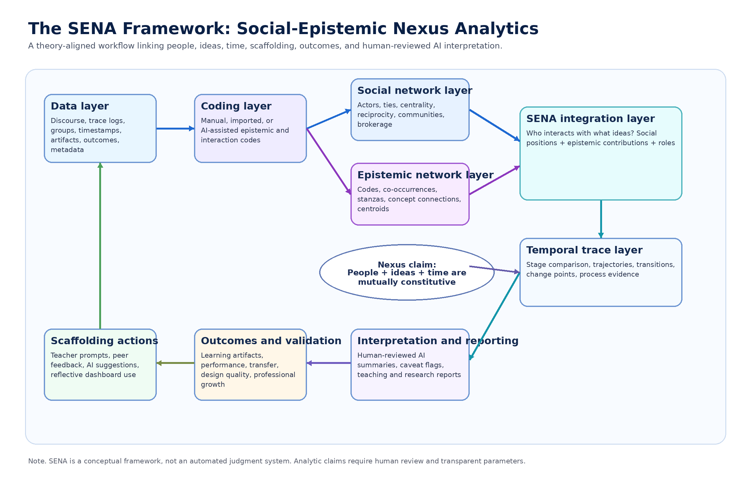
Figure 2. The SENA Framework. The framework connects data, coding, SNA, ENA, social-epistemic integration, temporal trace, scaffolding, outcomes, and human-reviewed interpretation.

4. Key constructs and analytic layers of SENA
SENA requires explicit construct definitions because each analytic choice has theoretical consequences. Actors may be learners, teachers, pre-service teachers, faculty members, AI agents, or other participants in a collaborative system. Discourse units may be posts, utterances, turns of talk, notes, replies, comments, design artifacts, or coded events. Epistemic codes may represent concepts, reasoning moves, inquiry practices, pedagogical moves, knowledge-building principles, or design-thinking categories. Social ties may be extracted from replies, mentions, co-editing, turn-taking, reading, building on notes, or other interaction events. Epistemic connections are usually defined as co-occurrences or meaningful associations among codes within a unit, stanza, moving window, episode, or activity segment.
The most distinctive SENA construct is the social-epistemic role. Roles are not inferred from centrality alone. They combine social position with epistemic contribution. A learner who connects otherwise separate peers and repeatedly links evidence to explanation may be a conceptual broker. A teacher who sustains participation while prompting reflection may be a relational facilitator. A student who repeatedly integrates critique, design constraints, and revision may be a content integrator. Such roles must be interpreted in relation to task, codebook, group norms, and temporal stage.
SENA also treats communities and temporal stages as first-class constructs. Communities can be identified through social interaction, epistemic similarity, task structure, or hybrid social-epistemic clustering. Temporal stages may be externally defined by instructional design, such as brainstorming, evidence building, and reflection, or empirically defined using windows and process markers. Both approaches require caution. Overly coarse stages may hide meaningful transitions; overly fine windows may produce unstable networks. The purpose of temporal SENA is not to create more graphs, but to explain how collaborative inquiry develops.
The analytic workflow contains seven layers. The data layer imports and structures trace data, discourse, group labels, timestamps, outcomes, and metadata. The coding layer converts raw discourse into analyzable epistemic and interaction codes through manual, imported, or AI-assisted procedures. The epistemic network layer builds ENA-style networks in which nodes are codes and edges are code connections. The social network layer builds actor networks and computes metrics such as density, centrality, reciprocity, and community structure. The social-epistemic integration layer overlays these outputs to examine how social positions correspond to epistemic patterns. The temporal comparison layer traces changes across stages, groups, or conditions. Finally, the interpretation and reporting layer translates quantitative and visual evidence into cautious, reproducible accounts for research or teaching.
This layered view is intentionally modular. A researcher may use only the Dual Lens Dashboard for exploratory analysis, the Fusion Canvas for role interpretation, or the Temporal Trace for process research. However, the full framework is strongest when layers are linked with transparent parameters. For example, a claim that evidence-explanation connections increased from Stage 1 to Stage 3 should be traceable to the coding scheme, units of analysis, window size, tie extraction rules, group selection, and visualization parameters. Without such traceability, attractive visualizations can undermine rather than support research credibility.
Table 2. SENA constructs, data sources, analytic operations, and outputs
Construct | Possible data sources | Analytic operations | Typical outputs
Actors | Learner IDs, teacher IDs, group membership, AI agent logs | Anonymize, map identities, assign roles and conditions | Actor lists, groups, demographic or role metadata
Discourse units | Posts, utterances, notes, comments, transcripts, artifacts | Segment, timestamp, align to actors and stages | Analyzable units and activity timelines
Epistemic codes | Codebook, manual coding, AI-assisted suggestions, imported labels | Apply codes, check reliability, audit disagreements | Code matrix, frequencies, reliability reports
Social ties | Replies, mentions, turn-taking, co-editing, reading or building-on events | Define tie rules, weight edges, filter thresholds | Actor network, density, centrality, reciprocity, communities
Epistemic connections | Coded discourse with units and windows | Construct co-occurrence networks, compare conditions | ENA networks, centroids, difference networks
Social-epistemic roles | SNA metrics combined with ENA profiles and discourse evidence | Interpret broker, facilitator, integrator, critic, maintainer roles | Role profiles and evidence-linked annotations
Temporal stages | Timestamps, instructional phases, episodes, sliding windows | Partition data, compare trajectories, identify transitions | Stage networks and SENA development paths
Scaffolding and outcomes | Teacher prompts, AI suggestions, artifacts, grades, performance criteria | Link interventions to subsequent patterns; validate with external outcomes | Feedback-response maps and validation models

5. The SENA system: A web-based instantiation of the SENA Framework
The SENA system is conceived as an AI-assisted research platform that turns collaborative discourse into transparent, comparable, and reproducible social-epistemic network evidence. Its purpose is not to replace existing statistical software, qualitative analysis, or researcher judgement. Rather, it is designed to lower barriers to theory-aligned network analytics by offering an end-to-end workflow from data import and coding to SNA, ENA, social-epistemic fusion, temporal analysis, interpretation support, and report generation.
At the time of writing, the system should be described as an under-development web prototype. The public site specified by the project is www.sena.hk, but the manuscript should not imply that the full platform is publicly available, stable, or empirically validated. The prototype screenshot in Figure 1 presents a design vision: a dashboard in which conversation streams, people networks, concept networks, fused people-ideas networks, temporal traces, and AI-assisted interpretation cards are visible in a unified interface. This design is aligned with learning analytics dashboard research, which stresses that dashboards should support meaningful interpretation rather than only display metrics (Jivet et al., 2018; Verbert et al., 2013; Wise & Jung, 2019).
The technical background provided by the development team identifies Next.js as the web development framework. Next.js is a React-based framework for building full-stack web applications (Vercel, n.d.). This matters pedagogically because a web-native implementation can support interactive visualizations, project workspaces, report exports, and browser/server workflows that are more accessible to researchers and educators who are not command-line users. The system is also planned to use jENA, a project-specific JavaScript implementation of ENA-style functionality inspired by rENA, and SNA.js, a project-specific JavaScript implementation of SNA functionality inspired by established R-based SNA tools. The existing rENA and sna packages provide important methodological continuity and benchmarking targets (Butts, 2024; Marquart et al., 2026).
The paper uses conservative language about these JavaScript modules because they are not treated here as independently published packages with verified versioned releases. jENA is described as a JavaScript-based ENA implementation for the SENA project, not as a validated replacement for all ENA software. SNA.js is described as a JavaScript-based SNA implementation for the prototype, not as a substitute for the mature R sna ecosystem. A future validation task is to benchmark outputs from jENA and SNA.js against established packages using shared datasets, parameter settings, and tolerances. Such benchmarking is essential if the system is to support publication-ready research.
Conceptually, the system architecture follows the SENA layers. Data sources flow into import and coding tools. Coded discourse feeds ENA-style modeling; interaction events feed SNA modeling. The fusion layer links actor positions, concept connections, social-epistemic links, and role profiles. Temporal tools compare stages and trajectories. AI-assisted interpretation drafts cautious summaries, caveat flags, and report text. Reproducibility exports should preserve codebooks, window settings, tie rules, filters, software versions, visual parameters, and audit logs. These design features are not decorative. They operationalize the idea that SENA is a research workflow, not a single graph.
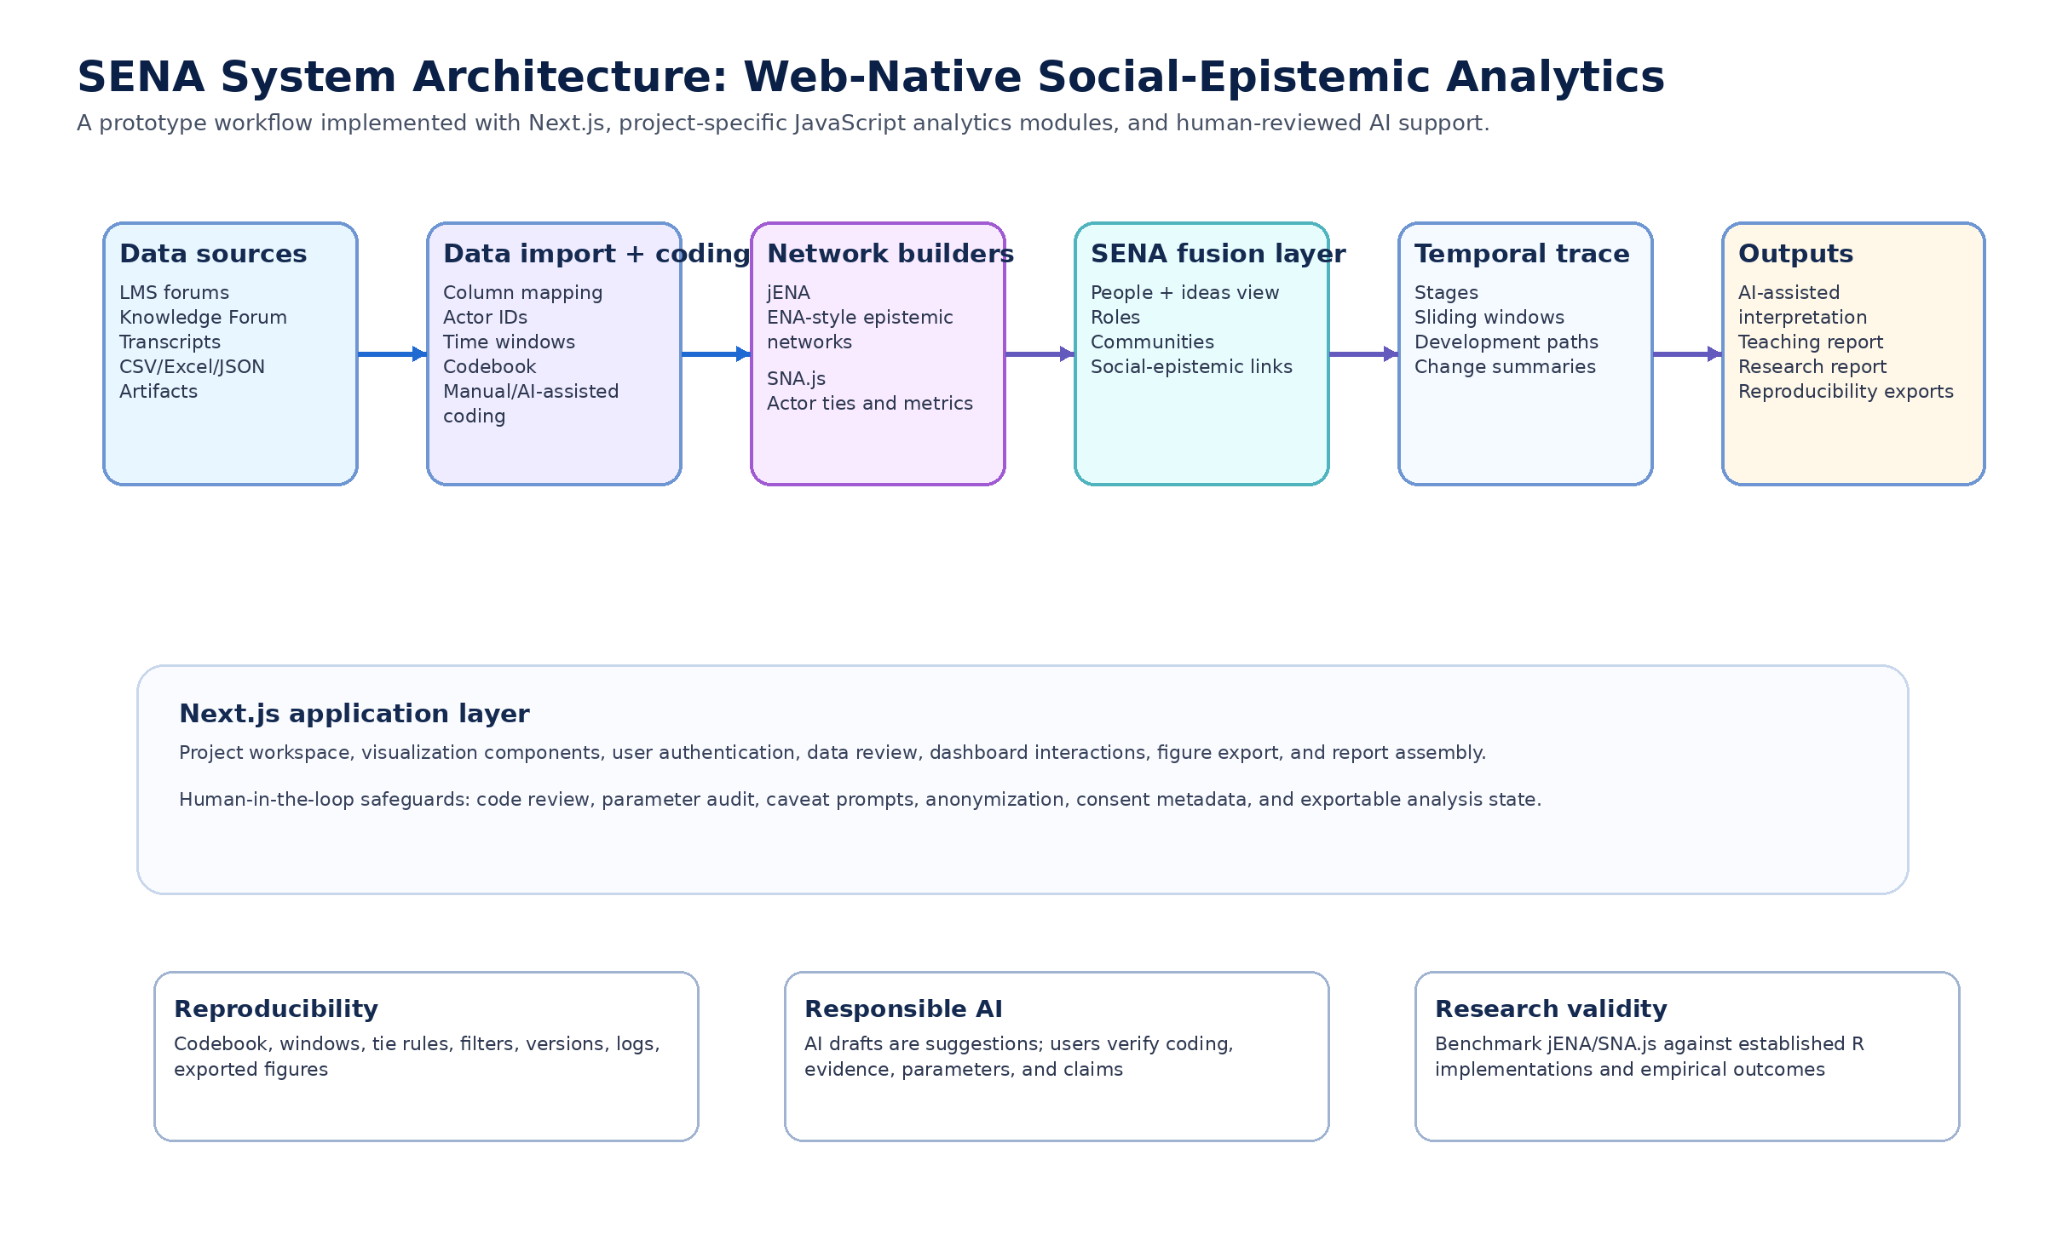
Figure 3. SENA system architecture. The architecture represents a web-native prototype that connects data import, coding, jENA, SNA.js, SENA fusion, temporal trace, AI-assisted interpretation, reports, and reproducibility exports.

6. Core function 1: Dual Lens Dashboard
The Dual Lens Dashboard is the prototype function that keeps the social and epistemic lenses visible but analytically distinguishable. In the screenshot, the left side presents a conversation stream with participant identifiers, timestamps, short discourse excerpts, and codes such as Question, Evidence, Explanation, Reflection, and Coordination. This design connects dashboard metrics back to inspectable discourse evidence. It helps prevent an analytics interface from becoming detached from the actual talk on which claims depend.
The central part of the Dual Lens Dashboard separates two network views. The SNA people network represents social ties among learners. In the screenshot, learner nodes are arranged as an actor network with line thickness or weight indicating tie strength. The ENA concept network represents connections among epistemic codes, including Question, Hypothesis, Evidence, Explanation, Reflection, and Coordination. This dual view allows users to ask two different but related questions: Who interacts with whom? and Which ideas or discourse moves are connected?
The right-side indicator panel provides summary evidence such as participation, centrality, concept diversity, and strongest concept link. These indicators are useful only when interpreted cautiously. Participation indicates activity but not necessarily productive engagement. Centrality indicates network position but not automatically leadership. Concept diversity indicates range but not necessarily depth. A strongest concept link, such as Evidence to Explanation in the screenshot, may signal productive reasoning, but it must be checked against coding quality and task context. SENA design therefore pairs indicators with conversation evidence and network views rather than presenting numbers as self-explanatory.
The theoretical value of the Dual Lens Dashboard is transparency. It resists two common reductions. The first reduction is to treat collaboration as participation volume. The second is to treat epistemic quality as code frequency or concept co-occurrence disconnected from social interaction. By showing SNA and ENA separately before fusion, the dashboard supports disciplined comparison. A teacher may notice that a learner is socially peripheral but conceptually important. A researcher may notice that a group has high interaction density but narrow epistemic range. A facilitator may notice that evidence appears frequently but is weakly linked to explanation or reflection.
For educational use, this function can support formative questioning rather than automatic intervention. Instead of telling a teacher that a learner is a leader or that a group is weak, the dashboard can prompt interpretation: Which learners connect peers? Which ideas are central? Are central learners also contributing to reasoning? Which discourse codes are isolated? Such questions align with dashboard research emphasizing that analytics should support situated decision-making by teachers and learners (van Leeuwen et al., 2019; Wise & Jung, 2019).

7. Core function 2: SENA Fusion Canvas
The SENA Fusion Canvas is the core system expression of the framework. It moves from juxtaposition to integration. In the screenshot, learner nodes and epistemic concept nodes are placed within a single canvas. Blue ties represent social relations among learners, purple dashed edges represent concept connections, and gradient links represent social-epistemic associations between people and ideas. The interface also includes a toggle among SNA, ENA, and SENA views, which allows users to move from separate lenses to an integrated people-ideas space.
The central question of the Fusion Canvas is not only who interacts or what concepts connect, but who interacts with what ideas. This question changes the meaning of network evidence. A learner who is central in the social network but weakly linked to the major epistemic connections may be coordinating without shaping conceptual progress. A learner who is not socially central but strongly linked to Evidence, Explanation, and Reflection may be a conceptual contributor who requires different recognition. A concept such as Question may serve as a starting point for inquiry, while Evidence and Explanation may become organizing concepts for deeper reasoning. These interpretations require discourse review, but the canvas makes them visible as analytic possibilities.
The Fusion Canvas can support the interpretation of social-epistemic roles. A broker links otherwise disconnected learners or communities while also connecting key concepts. A facilitator maintains participation and coordinates transitions among ideas. A content integrator connects evidence, explanation, critique, and reflection. A reflective critic links explanation to evaluation and future action. A relational maintainer sustains trust and participation, which may be essential during early stages even if the role is not immediately associated with advanced epistemic links. Such roles should be treated as hypotheses generated from combined evidence, not as fixed labels assigned by the system.
Fusion also creates risks. When a visualization combines multiple evidence types, users may over-read spatial proximity, line thickness, or node size. SENA design should therefore make parameters inspectable: how social ties were extracted, how epistemic connections were defined, how weights were normalized, and how social-epistemic links were computed. The system should also allow users to return from the fused view to the Dual Lens Dashboard and the underlying discourse stream. Fusion without traceability can become visually persuasive but methodologically opaque.
For research, the Fusion Canvas can support questions that are difficult to answer with either SNA or ENA alone. Do learners with similar epistemic profiles interact more? Are certain discourse patterns associated with brokerage or centrality? Do high-performing groups display different social-epistemic role distributions than low-performing groups? How do teacher prompts shift both social participation and epistemic connections? These questions follow the logic of SENS while extending it into a platform-based workflow for interactive inspection, comparison, and reporting (Gašević et al., 2019; Li et al., 2024).

8. Core function 3: Temporal SENA Trace
The Temporal SENA Trace addresses a crucial limitation of static network dashboards: collaborative learning unfolds over time. In the screenshot, the right panel divides the process into Stage 1 Brainstorming, Stage 2 Evidence Building, and Stage 3 Reflection. Each stage includes compact SNA and ENA views, allowing users to compare social connectivity and epistemic connections across the process. A development path below the stage panels traces changes in social connectivity, concept connectivity, and social-epistemic integration.
Temporal analysis is not merely a convenience feature. CSCL and learning analytics research has repeatedly argued that process matters: the order, timing, and transition of events can change the meaning of the same aggregate pattern (Knight et al., 2017; Reimann, 2009). A group that begins with many questions, then connects evidence to explanation, and finally links reflection to next steps may display a productive inquiry trajectory. Another group may show similar final code frequencies but without the same developmental sequence. Temporal SENA is designed to make these differences inspectable.
The Temporal SENA Trace can answer questions such as: How does collaboration evolve over time? When does a group move from questioning to evidence building or reflection? Which learner becomes a social bridge? Which epistemic links strengthen or weaken? How does a teacher or AI prompt relate to subsequent changes? The screenshot illustrates this logic through AI-assisted interpretation cards: learner C becomes a social bridge, the Evidence-Explanation connection strengthens, and the group moves from questioning to reflection. These statements are useful as draft interpretations, but they must remain connected to data, coding, parameters, and human review.
Temporal SENA also supports teacher orchestration. A teacher may use Stage 1 evidence to identify groups that are socially active but epistemically narrow, then prompt them to justify claims with evidence. During Stage 2, the teacher may look for whether evidence is being connected to explanation rather than listed without reasoning. During Stage 3, the teacher may examine whether reflection connects back to evidence and future action. The purpose is not to automate teacher judgment but to provide process evidence that can inform timely, situated support (van Leeuwen et al., 2019).
For the learning sciences, the Temporal SENA Trace opens opportunities to study human-AI collaboration as a developing system. If GenAI agents participate in discussions, suggest questions, or generate feedback, they become part of the social-epistemic ecology. SENA can help examine whether AI prompts diversify participation, concentrate attention, strengthen evidence-explanation links, or shift groups prematurely toward summary. Such research can contribute to theories of co-regulation and human-AI interaction by representing AI not simply as a tool but as a mediating participant whose effects are social, epistemic, and temporal (Luckin & Cukurova, 2019; Molenaar, 2022).
Table 3. Mapping SENA system functions to research questions and user actions
System function | Primary analytic question | User actions | Interpretive caution
Dual Lens Dashboard | Who interacts with whom, and which concepts are connected? | Inspect conversation stream, compare SNA and ENA views, review indicators, check discourse examples. | Do not equate participation with quality or centrality with leadership.
SENA Fusion Canvas | Who interacts with what ideas, and how do roles combine social position and epistemic contribution? | Toggle SNA/ENA/SENA, inspect social-epistemic links, compare role profiles, trace links to evidence. | Treat roles as hypotheses requiring discourse review and parameter transparency.
Temporal SENA Trace | How do social-epistemic patterns change across stages or windows? | Define phases, compare stage networks, examine trajectories, review AI draft interpretations. | Avoid causal claims unless design, timing, and alternative explanations are addressed.
AI-assisted interpretation | How can network evidence be summarized for reflection or reporting? | Generate drafts, review caveats, edit claims, link statements to data and methods. | AI-generated text is a draft; final claims belong to researchers or educators.
Report generator and exports | How can results be shared reproducibly? | Export figures, codebooks, parameters, methods notes, and audit logs. | Reproducibility depends on complete metadata and versioned analysis settings.

9. SENA in the GenAI era: Human-AI collaboration for learning analytics and learning sciences
Generative AI changes the practical conditions of learning analytics. It can help prepare data, suggest discourse codes, summarize group discussions, explain dashboard patterns in natural language, and draft teaching or research reports. These affordances are valuable because social-epistemic analysis can be technically demanding. Researchers need to prepare data, define units, create codebooks, model networks, interpret graphs, and write methods sections. Teachers need evidence that is timely and understandable. GenAI may help bridge these gaps when embedded in a human-in-the-loop workflow (Miao & Holmes, 2023; Molenaar, 2022).
SENA positions AI as an analytic partner rather than an authority. At the coding stage, AI can propose candidate labels or identify segments that need review. At the modeling stage, AI can explain what parameters mean and flag inconsistencies. At the interpretation stage, AI can generate cautious summaries such as “the Evidence-Explanation link appears stronger in Stage 2 than Stage 1” while linking the statement to the relevant graph and data. At the reporting stage, AI can draft methods notes and limitations. In each case, the human user remains responsible for approving codes, checking validity, interpreting context, and deciding what claims are justified.
This approach also recognizes that GenAI may become part of the learning process being analyzed. In AI-supported inquiry, students may ask a chatbot for explanations, critique AI-generated ideas, or use AI to generate evidence sources. Teachers may use AI to scaffold discussion. Researchers may use AI to interpret discourse. SENA offers a conceptual basis for representing these human-AI relations as social-epistemic relations: who takes up AI suggestions, what ideas are amplified, which learners become more central, and how AI-mediated feedback changes the temporal trajectory of inquiry.
The learning sciences contribution is therefore twofold. First, SENA can provide more nuanced evidence about collaborative learning by linking interaction structure, discourse content, roles, and time. Second, SENA can support new theoretical work on human-AI interaction. Rather than asking only whether AI improves performance, researchers can ask how AI changes participation, idea circulation, evidence use, reflective talk, and social-epistemic roles. These questions are consistent with calls for learning sciences-driven educational AI, where the design and evaluation of AI systems are guided by theories of learning rather than by technical capability alone (Luckin & Cukurova, 2019).
However, the GenAI orientation also increases ethical responsibility. AI may reproduce biases, misclassify discourse, overstate findings, or generate fluent but unsupported claims. If students are represented in dashboard summaries, such errors can have educational consequences. SENA therefore requires an explicit distinction between analytic evidence, AI-generated interpretation, and human decision. The system should display confidence, uncertainty, and caveat prompts where possible, and it should preserve audit trails for coding, filtering, and reporting decisions (Baker & Hawn, 2022; Slade & Prinsloo, 2013).

10. Design principles, responsible AI, and reproducibility
A SENA system should be guided by design principles that reflect both educational theory and responsible analytics. The first principle is theoretical alignment: every visualization and metric should map to a clear construct in the framework. The second is dual-lens transparency: users should be able to inspect social and epistemic evidence separately before interpreting fusion. The third is fusion without reduction: integrated views should not collapse people into concepts or concepts into social metrics. The fourth is temporal traceability: claims about development should be linked to stages, windows, and timestamps. The fifth is human-in-the-loop AI: automated suggestions should remain reviewable, editable, and contestable.
Reproducibility by design is equally important. Network visualizations can change dramatically with different window sizes, tie thresholds, coding schemes, or normalization choices. Publication-ready SENA reports should therefore export not only figures but also codebooks, data dictionaries, tie extraction rules, ENA units and stanzas, filtering decisions, software versions, and analytic logs. Reproducibility does not mean that interpretation becomes mechanical. It means that another researcher can understand how the evidence was produced and can examine whether alternative choices would change the conclusion.
Ethical and privacy-aware analytics should be built into the workflow rather than appended at the end. Data import should support anonymization of names and identifiers. Projects should record consent and ethics metadata when required. Role-based access control should limit who can view identifiable data. AI-assisted coding should display human verification status and avoid presenting unreviewed labels as facts. Dashboard interpretations should warn against deficit labeling of individuals or groups. These safeguards are consistent with broader concerns about learning analytics ethics, fairness, and responsible AI (Baker & Hawn, 2022; Slade & Prinsloo, 2013; Shneiderman, 2020).
The interpretability principle is also practical. Teachers and researchers should be able to move from a summary statement to the network evidence and then to the original discourse examples. For instance, if the system states that a group’s reflection link increased, the user should be able to see which coded discourse units contributed to the connection. If the system identifies a learner as a bridge, the user should be able to inspect the tie rules and discourse excerpts. This evidence chain can help prevent dashboards from becoming black boxes.
Table 4. Responsible AI and reproducibility checklist for SENA
Risk | Design response | Researcher or educator responsibility | System support
Privacy exposure | Anonymization, role-based access, consent metadata, secure project spaces. | Collect only necessary data and follow institutional ethics requirements. | PII masking, access logs, ethics fields, export controls.
AI coding error | AI suggestions are separated from verified codes. | Review samples, calculate reliability where appropriate, document disagreements. | Confidence flags, human verification status, code audit panels.
Over-interpretation of centrality | Centrality is displayed with discourse and role evidence. | Avoid equating centrality with leadership or learning quality. | Caveat prompts and linked examples from conversation streams.
Opaque fusion visualizations | Users can inspect SNA, ENA, and SENA parameters separately. | Report tie rules, window sizes, weights, filters, and normalization choices. | Parameter panel, methods export, reproducibility bundle.
Unsupported AI claims | AI-generated interpretation is labeled as draft text. | Verify claims against data, graphs, statistics, and context before use. | Source-linked summaries, caveat flags, editable report sections.
Bias and deficit labeling | Avoid automatic negative labels and include fairness warnings. | Interpret patterns in relation to task, language, access, and group context. | Bias notices, group-level defaults, review prompts.
Non-reproducible reporting | Export analysis state alongside figures and text. | Archive codebook, data transformations, software versions, and report edits. | CSV/JSON exports, version logs, figure captions with parameters.

11. Research agenda and future validation
Because this paper is conceptual, future work must establish whether SENA indicators and system functions are valid, useful, and ethical in real educational contexts. The first validation need is methodological. jENA and SNA.js should be benchmarked against established implementations such as rENA and sna using shared datasets, identical parameters, and clear tolerance criteria. Differences should be documented and, where necessary, corrected before claims of equivalence are made. Benchmarking should include not only final graphs but also edge weights, normalization, centrality metrics, community detection, and exported methods text.
The second research need is construct validation. SENA roles, integration indices, and temporal trajectories should be compared with independent evidence such as expert discourse ratings, artifact quality, peer assessment, teacher observations, and learning outcomes. For example, if a learner is identified as a reflective broker, qualitative evidence should show that the learner connects peers and advances reflective reasoning. If a group’s social-epistemic integration increases, researchers should examine whether this increase corresponds to richer explanation, better artifacts, or improved collective regulation.
The third need is dashboard use research. Teachers may interpret dashboards differently depending on expertise, time pressure, pedagogical goals, and trust in AI. Studies should examine what teachers notice in the Dual Lens Dashboard, how they use the Fusion Canvas to plan interventions, and whether Temporal Trace views support timely orchestration. Such studies should avoid evaluating the dashboard only by satisfaction ratings. They should examine how analytics evidence changes instructional reasoning and action (van Leeuwen et al., 2019; Wise & Jung, 2019).
The fourth need is AI-assisted coding and interpretation research. SENA should evaluate whether AI suggestions improve efficiency without reducing validity. This requires comparing manual, AI-assisted, and hybrid coding workflows; measuring agreement and disagreement; and studying how users revise AI-generated reports. It also requires analyzing hallucinated or overstated claims. A useful AI interpretation should be evidence-linked, editable, and caveated, not merely fluent.
The fifth need is domain expansion. SENA can be examined in CSCL, knowledge building, teacher education, design thinking, inquiry learning, project-based learning, professional development, and GenAI-supported learning. These settings differ in discourse norms, artifact structures, and temporal rhythms. The framework should therefore remain configurable rather than impose a single codebook or stage model. Comparative studies can examine which SENA constructs generalize and which require domain-specific adaptation.
Finally, SENA can contribute to theory building about human-AI collaboration. Future studies might ask whether AI agents become epistemic brokers, whether human learners rely on AI in ways that alter social ties, or whether AI-generated feedback changes transitions between questioning, evidence building, explanation, and reflection. Such work should treat human-AI collaboration as a social-epistemic process rather than as a simple input-output intervention. This is where SENA may be most valuable for the learning sciences: it gives researchers a language and analytic architecture for studying how people, ideas, tools, and AI agents co-develop over time.

12. Conclusion
SENA offers a conceptual framework for learning analytics in which people, ideas, and time are modeled as a dynamic nexus. It builds on SNA, ENA, social learning analytics, and SENS, but extends them toward a broader analytic ecosystem that includes roles, communities, temporal stages, scaffolding, outcomes, AI-assisted interpretation, and reproducibility. The shift from signature to nexus is more than terminological. It signals a move from final patterns to evolving relations, from separate evidence streams to integrated interpretation, and from visual analytics to theory-guided analytic workflow.
The SENA system prototype described in this paper demonstrates how the framework can guide educational technology design. The Dual Lens Dashboard keeps social and epistemic evidence transparent. The SENA Fusion Canvas asks who interacts with what ideas and supports social-epistemic role interpretation. The Temporal SENA Trace follows how collaborative inquiry develops across stages. Together, these functions operationalize the argument that collaborative learning should be represented through people-ideas-time relations rather than through participation counts, concept frequencies, or isolated network graphs.
In the GenAI era, the central promise of SENA is not full automation. It is human-centered social-epistemic intelligence: AI can assist coding, interpretation, and reporting, but analytic claims must remain linked to data, theory, transparent parameters, and human judgement. If validated responsibly, SENA may support researchers, teachers, and learning scientists in understanding how collaboration evolves, how ideas circulate, how roles emerge, and how human-AI systems reshape learning. The next step is empirical and methodological validation, not premature certainty. The value of SENA will depend on whether it helps educational communities interpret learning more carefully, act more responsibly, and build stronger theories of collaborative knowledge work.

CRediT author statement
Dongpin Hu: Conceptualization, system design, writing - original draft. Yun-Fang Tu: Conceptualization, educational technology perspective, writing - review and editing. Dragan Gašević: Learning analytics methodology, writing - review and editing. David W. Shaffer: Epistemic network analysis and quantitative ethnography perspective, writing - review and editing. Gwo-Jen Hwang: Supervision, conceptual guidance, correspondence, writing - review and editing. This statement is a proposed draft and should be confirmed by all authors before submission.

Declaration of competing interest
The authors should declare any financial or non-financial interests related to the SENA system before submission. Draft statement: The authors declare no competing interests. [To be verified by all authors.]

Data availability statement
No empirical dataset was analyzed in this conceptual paper. The system description is based on an internal framework document, a prototype design screenshot, and developer-provided technical notes. Future empirical studies should make de-identified data, codebooks, parameters, and reproducibility materials available when ethically and legally permissible.

Acknowledgements
The authors acknowledge the SENA/ENAHK project materials and prototype design that informed this conceptual manuscript. Any funding information should be inserted before submission. [Funding statement to be verified.]

References
Amershi, S., Weld, D., Vorvoreanu, M., Fourney, A., Nushi, B., Collisson, P., Suh, J., Iqbal, S., Bennett, P. N., Inkpen, K., Teevan, J., Kikin-Gil, R., & Horvitz, E. (2019). Guidelines for human-AI interaction. In Proceedings of the 2019 CHI Conference on Human Factors in Computing Systems (pp. 1-13). Association for Computing Machinery. https://doi.org/10.1145/3290605.3300233
Baker, R. S., & Hawn, A. (2022). Algorithmic bias in education. International Journal of Artificial Intelligence in Education, 32(4), 1052-1092. https://doi.org/10.1007/s40593-021-00285-9
Buckingham Shum, S., & Ferguson, R. (2012). Social learning analytics. Educational Technology & Society, 15(3), 3-26.
Butts, C. T. (2008). Social network analysis with sna. Journal of Statistical Software, 24(6), 1-51. https://doi.org/10.18637/jss.v024.i06
Butts, C. T. (2024). sna: Tools for Social Network Analysis (Version 2.8) [R package]. CRAN. https://doi.org/10.32614/CRAN.package.sna
Dillenbourg, P. (1999). What do you mean by collaborative learning? In P. Dillenbourg (Ed.), Collaborative learning: Cognitive and computational approaches (pp. 1-19). Elsevier.
Ferguson, R. (2012). Learning analytics: Drivers, developments and challenges. International Journal of Technology Enhanced Learning, 4(5/6), 304-317. https://doi.org/10.1504/IJTEL.2012.051816
Gašević, D., Dawson, S., & Siemens, G. (2015). Let's not forget: Learning analytics are about learning. TechTrends, 59(1), 64-71. https://doi.org/10.1007/s11528-014-0822-x
Gašević, D., Joksimović, S., Eagan, B. R., & Shaffer, D. W. (2019). SENS: Network analytics to combine social and cognitive perspectives of collaborative learning. Computers in Human Behavior, 92, 562-577. https://doi.org/10.1016/j.chb.2018.07.003
Jeong, H., & Hmelo-Silver, C. E. (2016). Seven affordances of computer-supported collaborative learning: How to support collaborative learning? How can technologies help? Educational Psychologist, 51(2), 247-265. https://doi.org/10.1080/00461520.2016.1158654
Jivet, I., Scheffel, M., Specht, M., & Drachsler, H. (2018). License to evaluate: Preparing learning analytics dashboards for educational practice. In Proceedings of the 8th International Conference on Learning Analytics and Knowledge (pp. 31-40). Association for Computing Machinery. https://doi.org/10.1145/3170358.3170421
Knight, S., Wise, A. F., & Chen, B. (2017). Time for change: Why learning analytics needs temporal analysis. Journal of Learning Analytics, 4(3), 7-17. https://doi.org/10.18608/jla.2017.43.2
Li, Z., Oon, P.-T. E., & Chai, S. (2024). Examining the impact of teacher scaffolding in the knowledge building environment: Insights from students' interaction patterns, social epistemic networks, and academic performance. Education and Information Technologies, 29(14), 18501-18532. https://doi.org/10.1007/s10639-024-12535-z
Luckin, R., & Cukurova, M. (2019). Designing educational technologies in the age of AI: A learning sciences-driven approach. British Journal of Educational Technology, 50(6), 2824-2838. https://doi.org/10.1111/bjet.12861
Marquart, C. L., Swiecki, Z., Collier, W., Eagan, B., Woodward, R., & Shaffer, D. W. (2026). rENA: Epistemic Network Analysis (Version 0.3.1) [R package]. CRAN. https://doi.org/10.32614/CRAN.package.rENA
Miao, F., & Holmes, W. (2023). Guidance for generative AI in education and research. UNESCO. https://unesdoc.unesco.org/ark:/48223/pf0000386693
Molenaar, I. (2022). Towards hybrid human-AI learning technologies. European Journal of Education, 57(4), 632-645. https://doi.org/10.1111/ejed.12527
Reimann, P. (2009). Time is precious: Variable- and event-centred approaches to process analysis in CSCL research. International Journal of Computer-Supported Collaborative Learning, 4(3), 239-257. https://doi.org/10.1007/s11412-009-9070-z
Scardamalia, M., & Bereiter, C. (2006). Knowledge building: Theory, pedagogy, and technology. In R. K. Sawyer (Ed.), The Cambridge handbook of the learning sciences (pp. 97-118). Cambridge University Press.
Shaffer, D. W. (2017). Quantitative ethnography. Cathcart Press.
Shaffer, D. W., Collier, W., & Ruis, A. R. (2016). A tutorial on epistemic network analysis: Analyzing the structure of connections in cognitive, social, and interaction data. Journal of Learning Analytics, 3(3), 9-45. https://doi.org/10.18608/jla.2016.33.3
Shneiderman, B. (2020). Human-centered artificial intelligence: Reliable, safe & trustworthy. International Journal of Human-Computer Interaction, 36(6), 495-504. https://doi.org/10.1080/10447318.2020.1741118
Siemens, G. (2013). Learning analytics: The emergence of a discipline. American Behavioral Scientist, 57(10), 1380-1400. https://doi.org/10.1177/0002764213498851
Slade, S., & Prinsloo, P. (2013). Learning analytics: Ethical issues and dilemmas. American Behavioral Scientist, 57(10), 1510-1529. https://doi.org/10.1177/0002764213479366
Stahl, G., Koschmann, T., & Suthers, D. (2006). Computer-supported collaborative learning: An historical perspective. In R. K. Sawyer (Ed.), The Cambridge handbook of the learning sciences (pp. 409-426). Cambridge University Press.
van Leeuwen, A., Rummel, N., & van Gog, T. (2019). What information should CSCL teacher dashboards provide to help teachers interpret CSCL situations? International Journal of Computer-Supported Collaborative Learning, 14, 261-289. https://doi.org/10.1007/s11412-019-09299-x
Vercel. (n.d.). Next.js documentation. Retrieved May 27, 2026, from https://nextjs.org/docs
Verbert, K., Duval, E., Klerkx, J., Govaerts, S., & Santos, J. L. (2013). Learning analytics dashboard applications. American Behavioral Scientist, 57(10), 1500-1509. https://doi.org/10.1177/0002764213479363
Wasserman, S., & Faust, K. (1994). Social network analysis: Methods and applications. Cambridge University Press.
Wise, A. F., & Jung, Y. (2019). Teaching with analytics: Towards a situated model of instructional decision-making. Journal of Learning Analytics, 6(2), 53-69. https://doi.org/10.18608/jla.2019.62.4
Zhao, Y., Xu, Y., Pan, D., Li, J., Long, T., & Dai, Z. (2026). Understanding how pre-service teachers and faculty design and implement an AI-integrated science course in interdisciplinary lesson study: A social epistemic network signature approach. Educational Technology Research and Development. Advance online publication. https://doi.org/10.1007/s11423-026-10616-z

